# Multi-touch attribution implementation guide

## Project scenario

Multi-touch attribution is essential for understanding how various marketing channels contribute to customer conversions. As the digital marketing analyst at Friska, you are in charge of developing a multi-touch attribution implementation guide. The company’s goal is as follows:

* Focus on targeting male customers for the next 12 months and increase sales by 20% in the U.S. market.

## Step-by-step instructions

### Step 1: Define your goals.

First, clearly define your goal and specify your target audience.

What is Friska’s goal? Is it SMART? Why or why not? Write your answer in the space below.

| ***Friska’s goal*** |  |
| --- | --- |

Who is Friska’s target audience? Write your answer in the space below.

| ***Friska’s target audience*** |  |
| --- | --- |

Add Friska’s goal and target audience to the [Multi-touch attribution implementation guide slides template](https://docs.google.com/presentation/d/1L5jCsI1m16i3gIBvEx4DEEPuYvEOGCQpec4B_wlCTeM/copy#slide=id.p).

### Step 2: Identify key metrics.

Determine the key performance indicators (KPIs) relevant to Friska’s goal, such as sales revenues, sales conversion rate, website traffic, and ROI.

Select a specific metric to track in order to assess if you are reaching Friska’s goal. Write your answer in the space below.

| ***Metric to track*** |  |
| --- | --- |

### Step 3: Data collection and integration

Ensure that you have a robust data collection system in place, integrating data from all relevant sources like website analytics, customer relationship management (CRM) software, email marketing management software, social media accounts, and online advertising platforms.

Based on the metric you decided to track in step 2, which tracking tool would you use? Write your answer in the space below.

| ***Tracking tool*** |  |
| --- | --- |

### Step 4: Customer segmentation

Segment your male customers based on demographics, interests, and behaviors to understand their preferences and behaviors better.

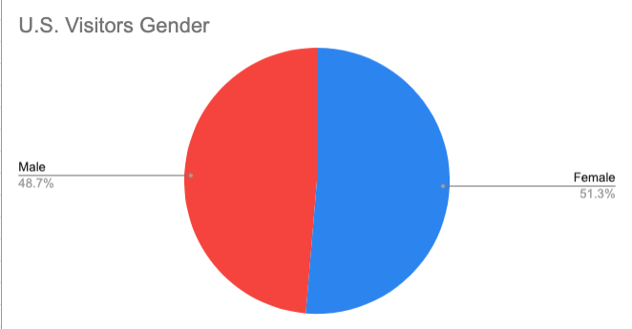

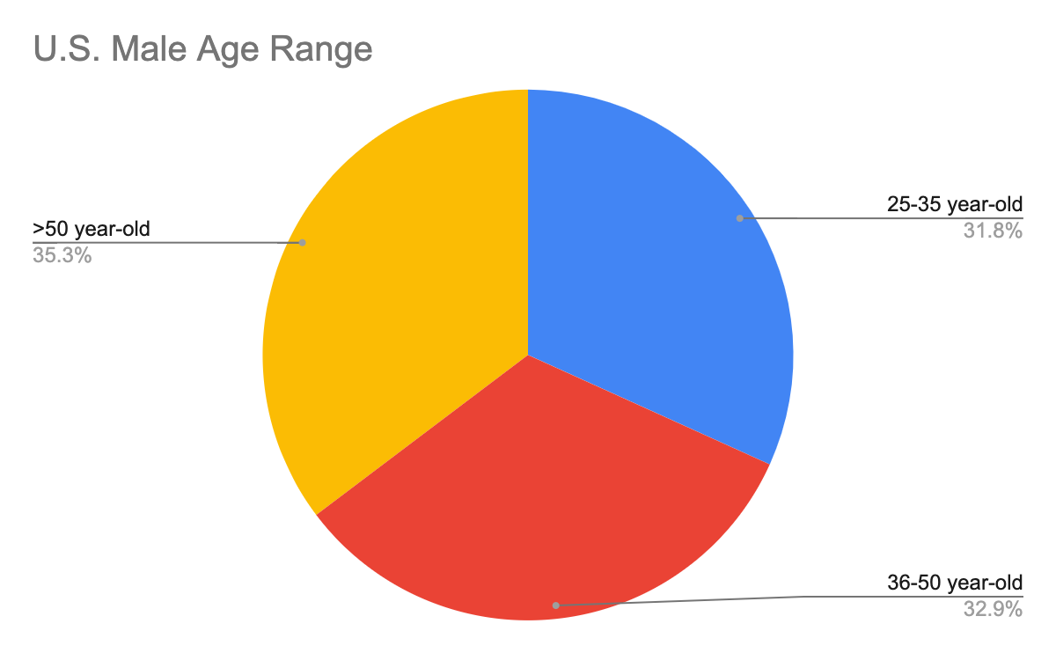

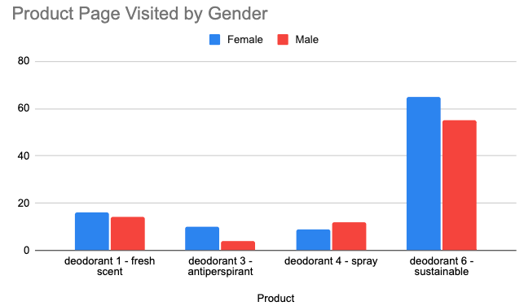

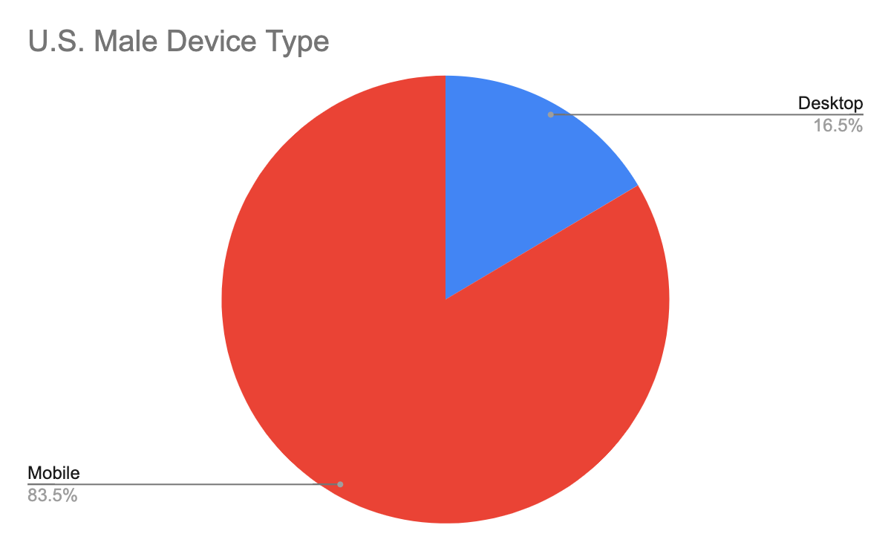

### Step 5: Attribution model selection

Choose an attribution model that suits your business. Common models include first-touch, last-touch, linear attribution, and time delay. For complex customer journeys, consider using a custom attribution model. Here’s a quick reminder and explanation of the common attribution models:

* **First-touch:** This model gives full credit for a purchase to the first touchpoint a customer has with a brand.
* **Last-touch:** This model assigns all credit for a sale to the last touchpoint the customer has with your marketing efforts.
* **Linear attribution:** This model gives equal credit to each touchpoint in the customer journey.
* **Time decay:** This model assigns credit to different touchpoints based on the idea that the closer a touchpoint is to the conversion, the more credit it should get.

Consider Friska’s objective, the KPI you chose to measure, and the tool you chose to measure the KPI. Which attribution model would you choose and why? Write your answer in the space below.

| ***Attribution model*** |  |
| --- | --- |

With a real company there will be numerous variables and options of tools to choose from. Because of this, there is not a correct or wrong attribution to use. It is important to validate your reasoning for choosing the attribution to stakeholders.

### Step 6: Multi-touch attribution process

Implement your chosen attribution model. For this activity, create a first-touch attribution model. This may require the use of attribution software. A reminder of what a first-touch attribution model looks like is below:

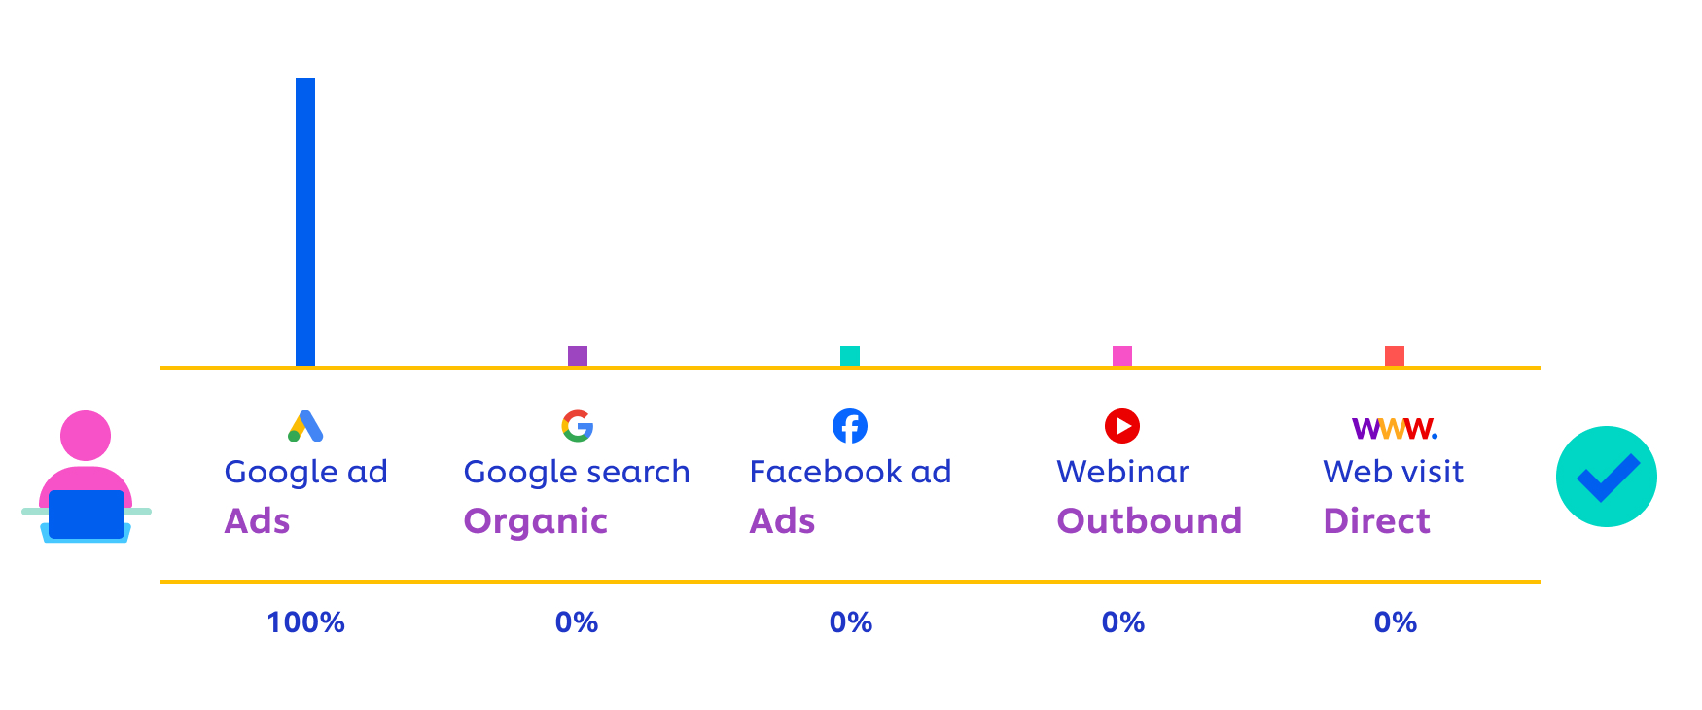

Touchpoints could include ads, emails, direct website visits, social media, and a search engine organic search.

List the touchpoints in your first-touch attribution model for Friska. Write your answer in the space below.

| ***First-touch attribution touchpoints*** |  |
| --- | --- |

Add the touchpoint in your first-touch attribution model for Friska to the [Multi-touch attribution implementation guide slides template](https://docs.google.com/presentation/d/1L5jCsI1m16i3gIBvEx4DEEPuYvEOGCQpec4B_wlCTeM/edit#slide=id.p).

### Step 7: Data analysis

Regularly analyze the attribution data to identify the channels and touchpoints that are most effective in driving male customers to convert.

Why is it important to analyze touchpoints? Write your answer in the space below.

| ***Touchpoint analysis*** |  |
| --- | --- |

### Step 8: Optimize marketing channels.

Allocate your marketing budget based on the insights gained from the attribution model. Focus more on the channels and touchpoints that contribute significantly to conversions. Optimize ad spend by identifying underperforming campaigns and reallocating resources.

### Step 9: Customize marketing campaigns.

Tailor marketing messages and campaigns specifically for male customers based on their preferences and behaviors. Develop engaging and relevant content that resonates with male customers. This content should align with their interests and values, emphasizing sustainability and the benefits of Friska's deodorants.

Practice by writing two marketing messages specifically for Friska male customers. Write your answer in the space below.

| ***Message #1*** |  |
| --- | --- |
| ***Message #2*** |  |

Add the two marketing messages to the [Multi-touch attribution implementation guide slides template](https://docs.google.com/presentation/d/1L5jCsI1m16i3gIBvEx4DEEPuYvEOGCQpec4B_wlCTeM/edit#slide=id.p).

### Step 10: A/B testing

Conduct A/B testing to further refine your marketing strategies. Test different ad creatives, messaging, and content layouts of landing pages to find the most effective combinations.

Design two separate A/B tests. Each A/B test should test a different, single variable. Examples of variables to test include:

* Call-to-action text
* Content layout on a landing page
* Color scheme
* Images
* Pricing strategy
* Product description
* Timing of when marketing messages are sent

Add the two A/B tests you designed to the [Multi-touch attribution implementation guide slides template](https://docs.google.com/presentation/d/1L5jCsI1m16i3gIBvEx4DEEPuYvEOGCQpec4B_wlCTeM/edit#slide=id.p).

### Step 11: Email marketing

Implement personalized email marketing campaigns targeted at male customers. Use segmentation to send relevant product recommendations and offers.

Analyze Friska’s current email below and provide recommendations on changing the subject line and content to optimize its relevance.

Subject: Stay active with Friska's deodorants!

Hello [First name],

At Friska, we're committed to helping you stay fresh, confident, and environmentally conscious, all at the same time. As a valued male customer, we've tailored this email just for you, featuring our best deodorant products and exclusive offers.

**Recommendations**

Classic Freshness: Our Classic Fresh Deodorant is a timeless favorite among our male customers. Its long-lasting formula will keep you feeling clean and odor-free throughout the day, whether you're at the office, hitting the gym, or just enjoying a day out.

Forest Breeze: Experience the refreshing scent of nature with our Forest Breeze Deodorant. The combination of natural fragrances will transport you to a tranquil forest, making it perfect for outdoor enthusiasts and nature lovers.

Ultimate Strength: For those who need extra protection, we recommend our Ultimate Strength Deodorant. Designed to stand up to the most challenging situations, it ensures you stay dry and comfortable, even in the most demanding conditions.

**Exclusive offers**

To show our appreciation for your loyalty, we're offering you an exclusive deal: Buy 2, Get 1 Free! Purchase any two Friska deodorants, and we'll add a third one for free. Simply use the code **MALEFRESH** at checkout.

**Why choose Friska**

Friska is dedicated to sustainability. Our deodorants are:

* **Eco-friendly**: We use recyclable and biodegradable packaging, minimizing environmental impact.
* **Cruelty-free**: Our products are never tested on animals.
* **Natural ingredients**: We prioritize safe and natural ingredients for your skin's health.

**Stay connected**

Join our Friska community on social media to stay updated on sustainable living tips, product launches, and exclusive contests:

* [Facebook](https://www.facebook.com/friska)
* [Instagram](https://www.instagram.com/friska)
* X

Thank you for being a valued Friska customer. We look forward to helping you maintain freshness and sustainability with our deodorants. Don't miss out on our exclusive offer to stock up on your favorites!

If you have any questions or need assistance, feel free to reply to this email. Your satisfaction is our top priority.

Stay fresh, stay Friska!

Friska’s team

Add your recommendations to the [Multi-touch attribution implementation guide slides template](https://docs.google.com/presentation/d/1L5jCsI1m16i3gIBvEx4DEEPuYvEOGCQpec4B_wlCTeM/copy#slide=id.p) to review with stakeholders.

### Step 12: Social media engagement

Increase your presence on social media platforms popular among male audiences. Share engaging content, run targeted ads, and encourage user-generated content.

### Step 13: Influencer marketing

Collaborate with male influencers who align with Friska's brand values. Their endorsements can help reach a wider male audience.

### Step 14: Customer feedback, monitoring, and iteration

Continuously collect and analyze customer feedback to improve product quality and customer service. Regularly review and assess the progress toward your 20% sales increase target. Make adjustments to your strategy as needed.

### Step 15: Reporting and communication

Create regular reports on attribution results and sales performance to keep all stakeholders informed and aligned.

Ensure that the necessary information has been added to the [Multi-touch attribution implementation guide slides template](https://docs.google.com/presentation/d/1L5jCsI1m16i3gIBvEx4DEEPuYvEOGCQpec4B_wlCTeM/edit#slide=id.p). Select from the different slide theme options to make it your own! In real life, don’t forget to design the presentation following your company’s brand identity guidelines (e.g., fonts, colors, iconography).

When you’re ready, go back to [the assignment](https://www.coursera.org/learn/campaign-performance-reporting-visualization-improvement/assignment-submission/Fs17H/multi-touch-attribution-implementation-guide) to complete the reflective questions.